1. **Adding Stub.**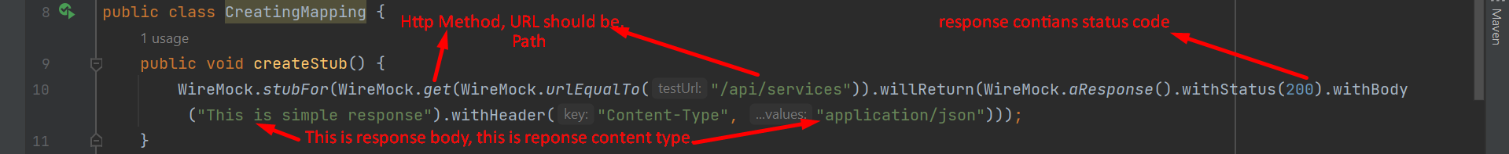
2. **Calling Test Method: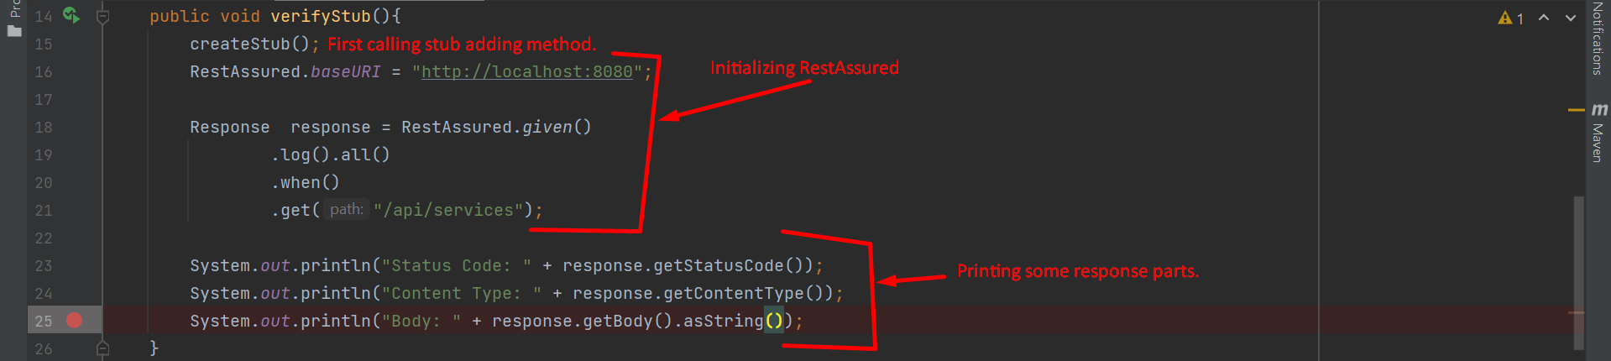 Console Output and you can see what stub we added the same we received as response.**